20/05/25
THM 415: Finance
Final Exam Answer Sheet
1. Why shall firms ignore interest payments and other financing costs while estimating cash flows for new projects? (2 Points)
Firms shall ignore interest payments and other financing costs while estimating cash flows for new projects since these very costs are accounted for in the cost of capital (i.e., discount rate) used to discount the project’s cash flows. Therefore, including such costs will lead to double counting.
2. The following depicts Corporate Bonds Spread Table:
Rafa Corporation is considering issuing bonds that will mature in 30 years with 5.16 % annual coupon rate. The interest will be paid Quarterly. Rafa Corporation is hoping to get an A+ rating on its bonds. However, Rafa Corporation is not sure whether the new bonds will receive that very rating.
- What is the price of Rafa Corporation bond? (1 Point)
According to the above Corporate Bonds Spread Table, the yield to maturity on a A+ rated 30-year bonds shall be 3.95 % + 3.20 % = 7.15 %. Therefore, the price of Rafa Corporation bond shall be:
Bond Price (A+ rating) = - PV (7.15%/4, 30*4, (1000*5.16%)/4, 1000) = $ 754.88.
- What is the price of the bond if it gets an A- rating? (1 Point)
According to the above Corporate Bonds Spread Table, the yield to maturity on a A- rated 30-year bonds shall be 4.07 % + 3.20 % = 7.27 %. Therefore, the price of Rafa Corporation bond shall be:
Bond Price (A+ rating) = - PV (7.27%/4, 30*4, (1000*5.16%)/4, 1000) = $ 743.19.
3. Salih Company’s bonds mature in 19 years time and promise to pay 7.43 % coupon interest monthly. Suppose you purchase the bonds for $ 1,253.53.
a) What is Salih’s Company’s promised yield to maturity? (1 Point)
- Promised Yield to Maturity = Rate (19 * 12, (1000 * 7.43 %) / 12, -1253.53, 1000) ≈ 0.44 %.
Since this promised rate is a monthly rate, the promised yield to maturity shall be 0.44%*12 = 5.31 %.
b) Assume there is a 42 % probability of default on this bond and if the bond defaults, the bondholders will receive only 80 % of the principal and interest owed. What is the expected yield to maturity on this bond? (2 Points)
In case of default, I will get only 80 % of the principle (i.e., 80 % * 1,000 = $ 800) and 80 % of the payment (i.e., 80 % * (1,000 * 7.43 %) / 12 = $ 4.9533). Therefore, Yield to Maturity (Default) = Rate (19 * 12, 4.9533, -1253.53, 800) * 4 = 0.28 % * 12 = 3.38 %.
- Expected Yield to Maturity = (58 % * 5.31 %) + (42 % * 3.38 %) = 4.50 %.
4. Banza Corporation is considering three mutual exclusive investments. The projects’ expected net cash flows are as follows:
a) What is the Net Present Value of Projects A, B and C at an appropriate discount rate of 6.43%? (1.50 Point)
- NPV (Project A) = NPV (6.43%, 14250, 15250, 16250, -1903, 9500, -743, 10500, 11500, 12500, -843, 14250, 13250, 12250, -565, -475, 8500, 6500) – 77410 = $ 12,206.77.
- NPV (Project B) = NPV (6.43%, 7500, 8500, 9500, -550, 10500, 11500, -6850, 3500, 4500, 5500, 6500, 2500) – 35000 = $ 10,277.43.
- NPV (Project C) = NPV (6.43%, -3250, 6000, 7000, 8000, -7750, 7500, 8000, 6750) – 17500 = $ 5,541.60.
- What is the Equivalent Annual Cost of Projects A, B and C? (1.50 Point)
- EAC (Project A) = PMT (6.43%, 17, -12206.77, 0) = $ 1,201.37.
- EAC (Project B) = PMT (6.43%, 12, -10277.43, 0) = $ 1,254.92.
- EAC (Project C) = PMT (6.43%, 8, -5541.60, 0) = $ 907.64.
- What are the Payback Periods for Project A, B and C? (1.50 Points)
- Payback Period (Project A) = 8.22 Years.
- Payback Period (Project B) = 4.96 Years.
- Payback Period (Project C) = 3.97 Years.
- What are the MIRR’s for Project A, B and C? (3 Points)
- MIRR (Project A) = IRR(-80279.06, 14250, 15250, 16250, 0, 9500, 0, 10500, 11500, 12500, 0, 14250, 13250, 12250, 0, 0, 8500, 6500) = 8.88 %.
- MIRR (Project B) = IRR(-39857.01, 7500, 8500, 9500, 0, 10500, 11500, 0, 3500, 4500, 5500, 6500, 2500) = 11.67 %.
- MIRR (Project C) = IRR(-26228.85, 0, 6000, 7000, 8000, 0, 7500, 8000, 6750) = 10.84 %.
- Based on MIRR, which project shall be chosen? Why? (1 Point)
Based only on MIRR (there are problems with rankings of the projects if we don’t use NPV though), project B shall be chosen because its MIRR (11.67 %) is at the same time greater than discount rate (6.43 %) and the highest amongst other projects (all modified projects are conventional cash flow patterns).
5. Alpha Company is considering an independent project. The project’s expected net cash flows are as follows:
a) Calculate project’s IRR. (1 Point)
- IRR (Project) = IRR 600000, -550000, -550000, -550000, 1100000) = 6.20 %.
b) Draw the NPV profile for the project starting with a discount rate of 00% and increments of 5 % until you reach a discount rate of 50 %. (3 Points)
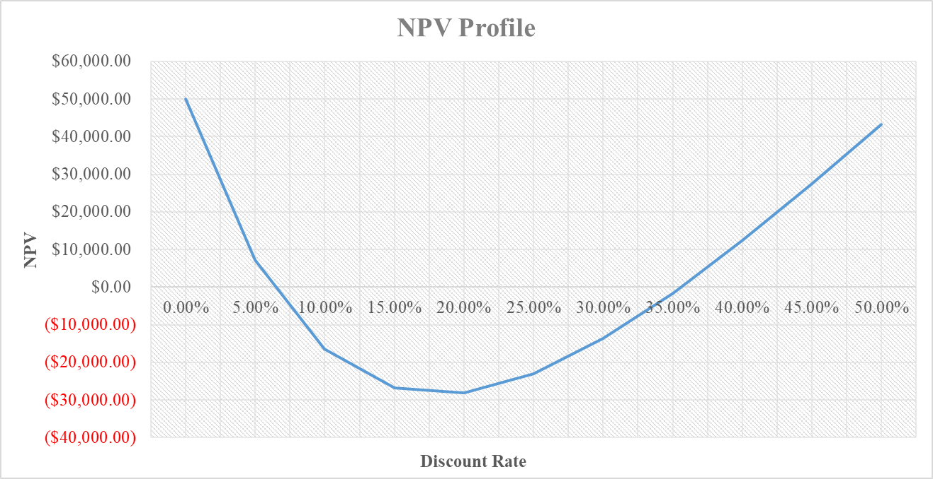
- Referring to the NPV Profile prepared in part b), what is the second IRR of the project? (2 Points)
The second IRR of the project occurs when the discount rate used is 35.59 %.
- What is your decision as far as to accept the project or reject it in [0%, 50 %] range of discount rates? (2 Points)
If the appropriate discount rate used to evaluate this very project is between 6.20 % and 35.59 %, reject the project. Otherwise, accept it.
6. Serv Travel, a company specialized in transfer transportation from the city of Ankara to Esenboğa Airport, is considering the purchase of a new fleet of 50 buses in its efforts to provide high quality services to its customers. If it goes through with the purchase, it will spend $ 1,500,000 on the 50 new buses. Each of those new buses is expected to benefit the company for 7 years, after which they will depreciated toward a $ 714,250 salvage value using straight-line depreciation. The buses are expected to have a market value in 7 years equal to their salvage value. The new buses will be used to replace company’s older fleet of the same number of buses which are fully depreciated but can be sold still for an estimated $ 155,980 (since the old buses have a current book value of zero, the selling price is fully taxable at the company’s 28.75 % marginal tax rate). The existing old buses fleet is expected to be useable for 7 more years after which time they will have no salvage value at all. Moreover, the existing old buses fleet uses $ 875,625 per year in diesel fuel, whereas the new, more efficient fleet will use only $ 425,618. Lastly, the new fleet will be covered under warranty, so the maintenance costs per year are expected to be only $ 4,500 compared to $ 17,500 for the existing fleet.
a) What are the differential operating cash flow savings per year during years 1 through 7 for the new fleet? (5 Points)
- What is the initial cash outlay required to replace the existing fleet with the newer buses? (1 Point)

- Sketch a timeline for the replacement project cash flows for years 0 through 7? (0.50 Points)
- If Serv Travel requires 9.03 % discount rate for new investments, use the profitability index to decide whether the fleet shall be replaced? (Show all necessary calculations)? (1 Point)
- PI = NPV (9.03%, 362164.36, 362164.36, 362164.36, 362164.36, 362164.36, 362164.36, 1076414.36) / (1388864.25) = 1.59 times.
→ Since PI is greater than 1, the fleet shall be replaced.
7. Hakan Corporation is evaluating the purchase of Erkutlu Corporation. As a first step, Hakan Corporation wants to determine the Weighted Average Cost of Capital (WACC) (i.e., the appropriate discount rate to discount future estimated cash flows of Erkutlu Corporation). In this regard, Hakan Company determined the following dollar values pertinent to the right hand-side of the balance sheet of Erkutlu Corporation:
- What is the weight attributed to each source of capital? (1 Point)
First of all, not all liability and owners’ equity accounts are source of capital. We have to discard accounts payable and accrued expenses. Moreover, we have to look at market values instead of book values. In this regard, the weight attributed to each source of capital is depicted in the following table:
While short debt is entirely coming from a loan obtained from a private bank with a yearly interest rate of 5.94 %, long term debt is entirely coming from a 17-year issued bond (with 16 years to maturity) 7.14 % coupon rate and interest paid on a semi-annual basis. The bond price is currently traded at $ 1,054.54. Lastly suppose that marginal tax rate is 33.26 %.
- What is the cost of short-term debt? (1 Point)
- Cost of short-term debt = 5.94 % *(1 – 33.26 %) = 3.96 %.
- What is the cost of long-term debt? (1 Point)
- Yield to maturity = Rate (16*2, (1000*7.14%)/2, - 1054.54, 1000) * 2 = 3.29 % * 2 = 6.58%.
- Cost of long-term debt = 6.58 % * (1 – 33.26 %) = 4.39 %.
- If preferred stocks issued by Erkutlu Corporation pays 8.43 % annual dividend and those very preferred stocks are traded currently at $ 903.54, what is the cost of preferred stock? (1 Point)
- Preferred stock dividend = 1,000 * 8.43 % = $ 84.30.
- Cost of preferred stock = (84.30 / 903.54) * 100 = 9.33 %.
Suppose that Erkutlu Corporation’s common stockholders have received dividends (pertaining to last year) of $ 7.43 per share and that very company’s common stocks are traded currently at $ 1,214.53 per share. Lastly, Round Corporation has paid the following dividends during the last 10 years:
- What is the cost of common stock? (1 Point)
Since geometric average takes into account the effect of compounding, it is a better measurement of the common stock growth rate.
- Growth Rate = 10.44 %
- Dividend 1 = 7.43 * (1 + 10.44 %) = $ 8.21
- Cost of common stock = (8.21 / 1214.53) + 10.44 % = 11.11 %.
- What is the Weighted Average Cost of Capital (WACC) of Erkutlu Corporation? (1 Point)
- Suppose Hakan Corporation is in need of $ 12,000,000 to finalize the acquisition of Erkutlu Corporation. Moreover, the amount needed will be financed 53 % through issuance of common stock and the remaining through issuance of bonds. Lastly, the intermediary bank responsible for the financing told that issue costs associated with bonds is 4.53 % while issue costs associated with equity is 7.14 %. What is the floatation cost associated with the acquisition of Erkutlu Corporation? (1 Point)
- Floatation cost of issuance of bonds = 4.53 %
- Weight of bonds in financing = 47 %
- Cost of issuance of common stock = 7.14 %
- Wight of common stocks in financing = 53 %
- Weighted average floatation cost = (47 % * 4.53 %) + (53 % * 7.14 %) = 5.91 %.
- Floatation cost associated with acquisition = 12,000,000 / (1 – 5.91 %) = $ 12,754,193.74.
Hakan Corporation uses Discounted Payback Period as the criterion to decide whether to finalize the purchase or not. Moreover, Hakan Corporation values 2.70 years as the cutoff period. Finally, the estimated cash flow generated from the purchase of Erkutlu Corporation for the next 10 years is depicted as the following:
- Shall the acquisition be finalized? Why? Why not? (Show all necessary calculations) (2 Points)
- Discounted Payback Period (Hakan Company) = 2.75 Years.
→ Since discounted payback period (i.e., 2.75 Years) is greater than cutoff period (i.e., 2.70 years), Hakan Corporation shall NOT finalize the acquisition of Erkutlu Corporation.
Good Luck

